**SMILE FARM**

**Software Requirement Specifications (SRS)**

**Version 1.0**

**Industrial Training & Presentation (ECS791)**

**BACHELOR OF TECHNOLOGY (CSE)**

|  |  |
| --- | --- |
| PROJECT GUIDES:  Internal Guides:  **Mr.Mahendra Singh Sagar**  **Ms.Deepti Aggarwal**  External Guide:  **Mr. Amit Kumar Roy** | SUBMITTED BY:  **Paras Rastogi (TCA1409048)**  **Swapnil Jain (TCA1409072)** |

July, 2017



**COLLEGE OF COMPUTING SCIENCES AND INFORMATION TECHNOLOGY**

**TEERTHANKER MAHAVEER UNIVERSITY, MORADABAD**

**Revision History**

|  |  |  |  |
| --- | --- | --- | --- |
| **Author/ Changes made by** | **Date** | **Reason For Changes** | **Version** |
| SMILE FARM DEVELOPERS | 13/08/2017 | initial draft | 1.0 draft 1 |
| SMILE FARM DEVELOPERS |  | baseline following changes after inspection | 1.0 approved |

**Approved by:**

**Project Guide Names:**

**Mr. Mahendra Singh Sagar Signature:**

**Ms. Deepti Aggarwal Signature:**

**Table of Contents**

1 Introduction 4

1.1 Purpose 4

1.2 Scope of the Work 4

1.3 Definitions, Acronyms, and Abbreviations 4

1.4 References 5

2 Overall Description 6

2.1 Product Perspective 6

2.2 Product Functions 6

2.3 User Characteristics 7

2.4 General Constraints 7

2.5 Assumptions and Dependencies 8

3 Specific Requirements 8

3.1 Farmer Registration Function 9

3.1.1 Description 9

3.1.2 Inputs 9

3.1.3 Processing 9

3.1.4 Outputs 9

3.1.5 Error Handling 9

3.1.6 Test Cases for Farmer Registration Function 9

3.2 E-Mail Notification Function 10

3.2.1 Introduction 10

3.2.2 Inputs 10

3.2.3 Processing 10

3.2.4 Outputs 10

3.2.5 Error Handling 10

3.2.6 Test Cases for Email Notification Function 10

3.3 Design Constraints 10

**Appendix A: Data Flow Diagram (DFD)**

**Appendix B: Entity-Relationship Diagram (ERD)**

**Appendix C: Use-Case Diagram (UCD)**

**Appendix D: Data Dictionary (DD)**

**Appendix E: Screen Shots**

|  |
| --- |
|  |

# Introduction

The SMILE FARM is a system that takes the latest information and knowledge inputs to the farmers so that they can improve their productivity and economic wellbeing by registering and addressing their issues on the designed community for effective communication and solutions.

## Purpose

The purpose of this document is to define scope and requirements of an agricultural initiative “Smile-Farm”. It is a vision of extending e-revolution to farmers and cooperatives through a three-pronged strategy:

a) Development of knowledge inputs and e-services of relevance to rural India.

b) Evolve effective dissemination strategies to encourage active use of the facilities by farmers & cooperatives.

c) The broad aim is to empower farmers and cooperatives through latest in information and communication technology.

## Scope of the Work

“Smile-Farm” will provide a secure user-id/password based login mechanism to access its services. Once logged in to the community, the user (Administrator/Content Manager/Subject Matter Expert, SME/Farmer) can use the services to fulfill their requirements. Login will be a prerequisite to use Smile-Farm. Internal users will be provided user id/password pair separately.

Once user logs in, s/he can view the dashboard of farmer queries with status, Latest Tips and Advisories added by SMEs are displayed.

## Definitions, Acronyms, and Abbreviations

|  |  |
| --- | --- |
| **Abbreviation** | **Description** |
| SME | Subject Matter Expert |

## References

|  |  |  |  |  |
| --- | --- | --- | --- | --- |
| **S#** | **Reference Details** | **Owner** | **Version** | **Date** |
|  | https://www.youtube.com/watch?v=xbtbo5sp9n8 | 360SMS |  |  |
|  | https://help.salesforce.com/ | Salesforce |  |  |
|  | <https://trailhead.salesforce.com/en> | Trailhead, Salesforce |  |  |

# Overall Description

Smile-Farm is a community that provides secure login mechanism to all its users to use services as per their requirements. Once logged in to the community, the user (Administrator/Content Manager/Subject Matter Expert, SME/Farmer) can use the services to fulfill their requirements. Login will be a prerequisite to use Smile-Farm. Internal users will be provided user id/password pair separately.

Once user logs in, s/he can view the dashboard of farmer queries with status, Latest Tips and Advisories added by SMEs are displayed.

## Product Perspective

The main purpose of Smile Farm is to take the latest information and knowledge inputs to farmers so that they can improve their productivity and improve their economic well-being.

The system contains features such as data tracking system for administrator, query module for farmers, response module for SME as well as real time notifications via e-mail and SMS to its users.

The context diagram for the smile farm is as follows:

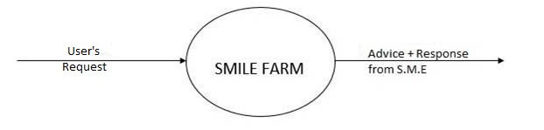

**to User**

Fig. 1: 0-Level DFD

## Product Functions

The main functions of the Smile-Farm are:

* Registering the farmers onto the smile farm to solve their queries.
* To provide the latest tips and advices for increasing farmer’s productivity.
* To provide an interactive community to farmers for effective interaction.
* Provides SMS and E-Mail support to the users.
* Raising Awareness among the farmers.

## User Characteristics

There are 4 types of users in the Smile-farm:

* **Administrator**: this is the user that has highest level of permission.

He can:

-Upload the data in bulk into the Smile Farm either by ApexDataLoader or by manual insertion.

-View/Add/Delete/Edit all the data present in the Smile Farm System.

-Can track how many records have been inserted/updated using the Smile Farm Tracking System designed in the dashboard.

-Generate Reports whenever required.

-Interact with all the other users using the Chatter Module in the Smile Farm.

* **Content Manager:** these are the managers of all the data present in the Smile Farm.

They can:

-View/Edit the data present in the Smile Farm.

-Interact with all the other users using the Chatter Module in the Smile Farm.

* **SME (SUBJECT MATTER EXPERT):** this is the group of people who are responsible for resolving the issues addressed and generated by the farmers.

They can:

-Post Tips and advices in the Smile Farm to keep the farmers updated and “aware”.

-Solve all the pending queries as well as the new queries raised by the farmers.

-Interact with all the other users using the Chatter Module in the Smile Farm.

* **Farmer:** this is the group of people for whom Smile Farm has been designed.

They can:

-Register themselves onto the Smile Farm to use its Services.

-Raise query to get relevant and appropriate answers.

-Get tips and advices from the SME for better practices of farming.

-Interact with all the other users using the Chatter Module in the Smile Farm.

-Get email alerts and SMS whenever their account is created and their query is resolved, respectively.

## General Constraints

All the modules of the Smile Farm must operate as part of the Smile Farm Community. It must adhere to all the Smile Farm standards and constraints.

## Assumptions and Dependencies

1. The system is ideally meant for farmers having mobiles for receiving SMS of the information they have subscribed to. For project scope, email id is being used for communicating.
2. The Project owner is familiar with Farming aids and initiatives taken by various organization for empowerment. They are eye openers from the technology point of view.

# Specific Requirements

Smile Farm is an independent cloud community and it will have a navigation menu on the top consisting of tabs (modules) as per the access privileges specified to each user by the administrator.

* **Chatter:** this is the default landing page of each user when logged into the Smile Farm community. This module enables the user for interacting with each other effectively.
* **Dashboards:** this module is made available to both the administrator as well as the content manager. Dashboard module consists of the “Smile Farm Tracking System” to keep track of all the records present in the Smile Farm.
* **Master Modules:** this module is made available to both the administrator as well as the content manager. Master modules include specific modules such as State Master, Location Master, Category Master and SME master.
* **Category Modules:** this module is made available to both the administrator as well as the content manager. Category Modules include specific module such as SME category for the data entry.
* **Reports:**  this module is visible to both the content manager as well as the administrator for creating and analyzing the prepared reports.
* **Query Module:** this module is only visible to the farmer for addressing their issues and posting their queries. All their queries are resolved by the SME via Resolved Queries/Pending Queries module.
* **Farmer Details Module:** this module is solely made available to the farmers and the SME for registering and responding to farmer’s queries respectively. This module can also be reached from the signup link in the Smile Farm community login page.

## Farmer Registration Function

### Description

This function has been designed to register new farmers into the Smile Farm Community.

This function will be triggered when the person clicks on the signup link in the smile farm community login page.

### Inputs

The function requires input data such as Name, DOB, Gender, Phone Number, Email, Address, City, Aadhaar Card and all other personal information to register the person as a new farmer.

### Processing

All the provided inputs gets stored into the Smile Farm cloud database to be accessed later.

### Outputs

All the input data gets reflected in the Farmer Details Module after registering.

### Error Handling

Error Handling is governed by the help of the below mentioned test cases.

### Test Cases for Farmer Registration Function

|  |  |  |  |  |
| --- | --- | --- | --- | --- |
| **Test Case ID** | **Test Title** | **Test Case Description** | **Pre-condition, if any** | **Expected Results** |
| TC001 | Data insertion | Providing the input data to the registration page for inserting all the data into the Smile Farm System. | None | Data inserted Successfully |
| TC002 | Data visibility | The registered data should be visible in the Farmer Details Module | None | Data visible in the Farmer Details Module |
| TC003 | Data Format | Stored data is in the designed format of the registration page | None | Stored Data is in the appropriate format. |

## 

## E-Mail Notification Function

### Introduction

This function will ensure that the Emails are sent to the farmer on his email-id when they register themselves into the Smile farm and also when the SME responds to their raised queries.

### Inputs

The email-id must be provided by the farmer during the time of registration.

### Processing

Email notification function gets triggered as soon as the farmer registers himself into the smile farm community. The e-mail id provided at the time of registration is used as input to supply the notifications to the farmers.

### Outputs

Emails are received by the farmer as per the designed template.

### Error Handling

Error Handling is governed by the help of the below mentioned test cases.

### Test Cases for Email Notification Function

|  |  |  |  |  |
| --- | --- | --- | --- | --- |
| **Test Case ID** | **Test Title** | **Test Case Description** | **Pre-condition, if any** | **Expected Results** |
| TC004 | Email Received after registration | The email should be received by the farmer on his registered email-id after signing up on the smile farm. | Email address required as input while filling the sign-up form. | Email Received. |
| TC005 | Email Received when SME replies to farmer’s query. | An email should be received by the farmer on his registered email id as soon as the SME responds to his/her query. | Email address required as input while filling the sign-up form. | Email Received. |

## Design Constraints

None.

**Appendix A**

**Data Flow Diagram (DFD)**

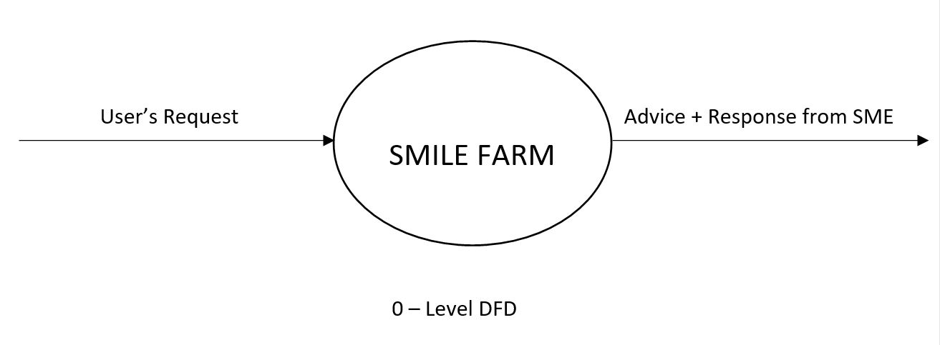

To User

Fig. 2: 0-Level DFD

**Appendix B**

**Entity-Relationship Diagram (ERD)**

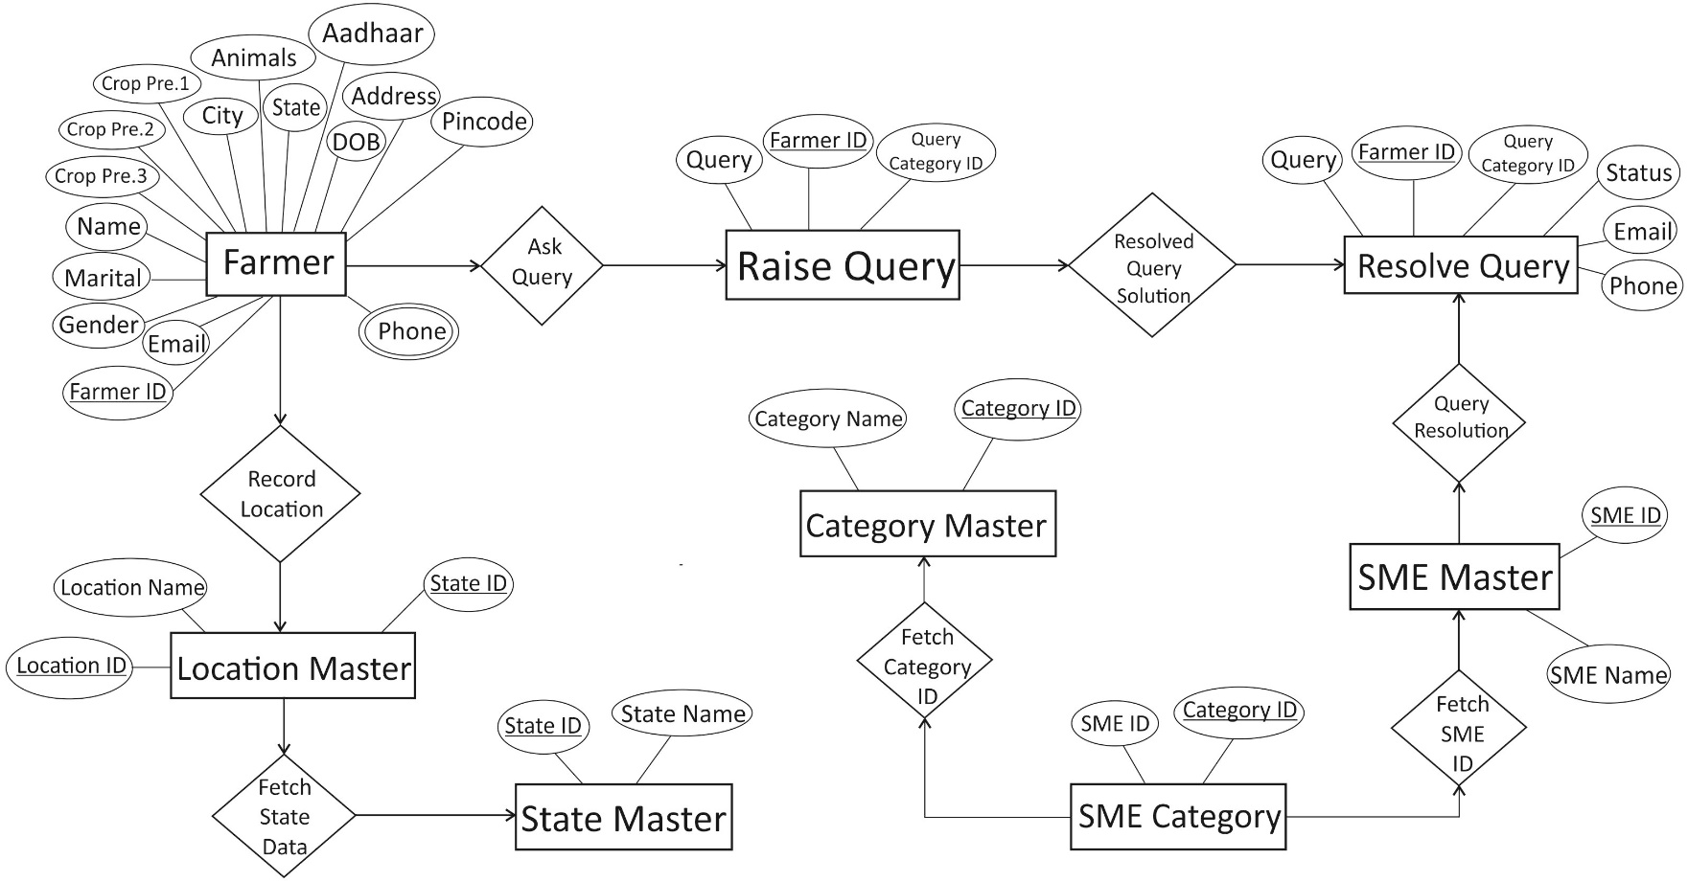

Fig. 3: ERD

**Appendix C**

**Use-Case Diagram (UCD)**

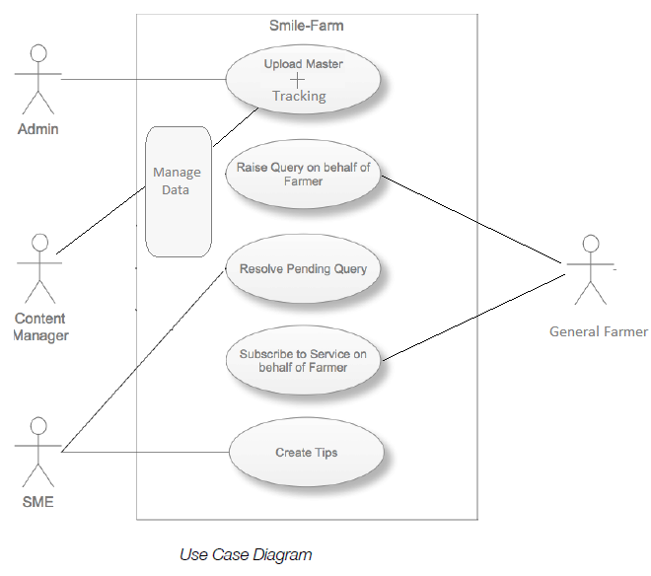

Fig. 4: UCD

**Appendix D**

**Data Dictionary (DD)**

**State Master Table:**

|  |  |  |
| --- | --- | --- |
| **Fields** | **Data type** | **Description** |
| State ID | NUMBER | It shows State ID |
| State Name | TEXT | It shows State Name |

**Location Master Table:**

|  |  |  |
| --- | --- | --- |
| **Fields** | **Data type** | **Description** |
| Location ID | NUMBER | It shows Location ID |
| Location Name | TEXT | It shows Location Name |
| State ID | NUMBER | It shows State ID |

**Category Master Table:**

|  |  |  |
| --- | --- | --- |
| **Fields** | **Data type** | **Description** |
| Category ID | NUMBER | It shows Category ID |
| Category Name | TEXT | It shows Category Name |

**SME Master Table:**

|  |  |  |
| --- | --- | --- |
| **Fields** | **Data type** | **Description** |
| SME ID | NUMBER | It shows SME ID |
| SME Name | TEXT | It shows SME Name |

**SME Category Table:**

|  |  |  |
| --- | --- | --- |
| **Fields** | **Data type** | **Description** |
| SME ID | NUMBER | It shows SME ID |
| Category ID | NUMBER | It shows Category ID |

**Raise Query Table:**

|  |  |  |
| --- | --- | --- |
| **Fields** | **Data type** | **Description** |
| Farmer ID | NUMBER | It shows Farmer ID |
| Query Category ID | NUMBER | It shows Query Category ID |
| Query | TEXT | It shows Query |

**Resolve Queries /Pending Queries Table:**

|  |  |  |
| --- | --- | --- |
| **Fields** | **Data type** | **Description** |
| Farmer ID | NUMBER | It shows Farmer |
| Phone Number | NUMBER | It shows Phone Number |
| Status | TEXT | It shows Status |
| Email | TEXT | It shows Email |
| Query ID | NUMBER | It shows Query ID |
| Query | TEXT | It shows Query |
| Solution | TEXT | It shows Solution |

**Farmer Detail Table:**

|  |  |  |
| --- | --- | --- |
| **Fields** | **Data type** | **Description** |
| Name | TEXT | It shows Name |
| Date of Birth | NUMBER | It shows Date of Birth |
| Gender | TEXT | It shows Gender |
| Marital Status | TEXT | It shows Marital Status |
| Phone | NUMBER | It shows Phone |
| Email | TEXT | It shows Email |
| Aadhaar Card | NUMBER | It shows Aadhaar Card |
| Address | TEXT | It shows Address |
| City | TEXT | It shows City |
| Pin code | NUMBER | It shows Pin code |
| States | TEXT | It shows States |
| Animals | TEXT | It shows Animals |
| Crop Preference 1 | TEXT | It shows Crop Preference 1 |
| Crop Preference 2 | TEXT | It shows Crop Preference 2 |
| Crop Preference 3 | TEXT | It shows Crop Preference 3 |

**Appendix E**

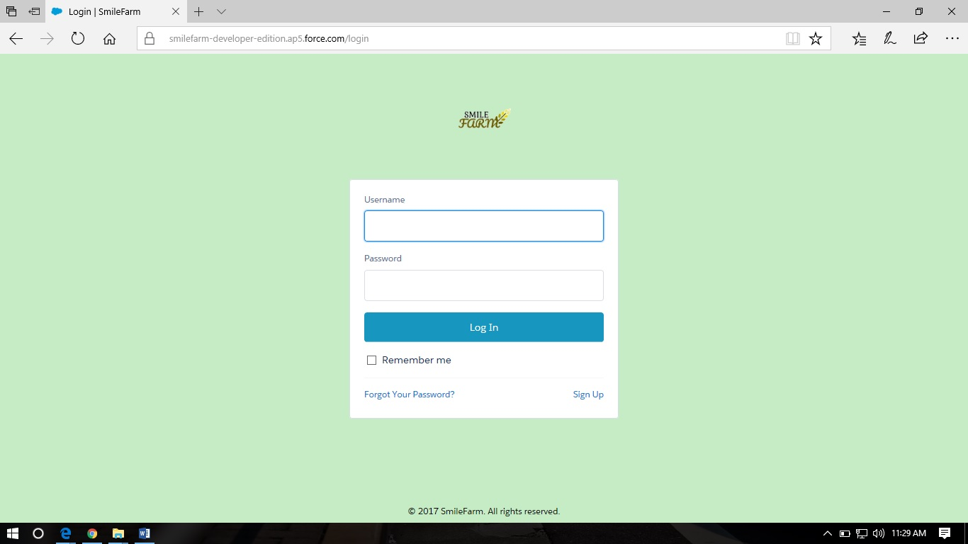**Screen Shots**

**Login Page:**

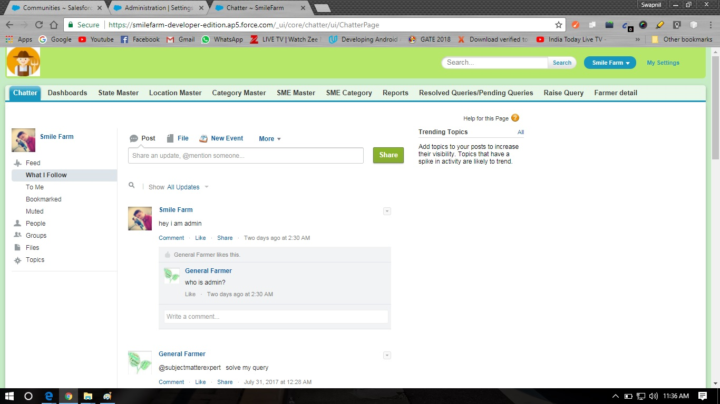**Admin Chatter Page:**

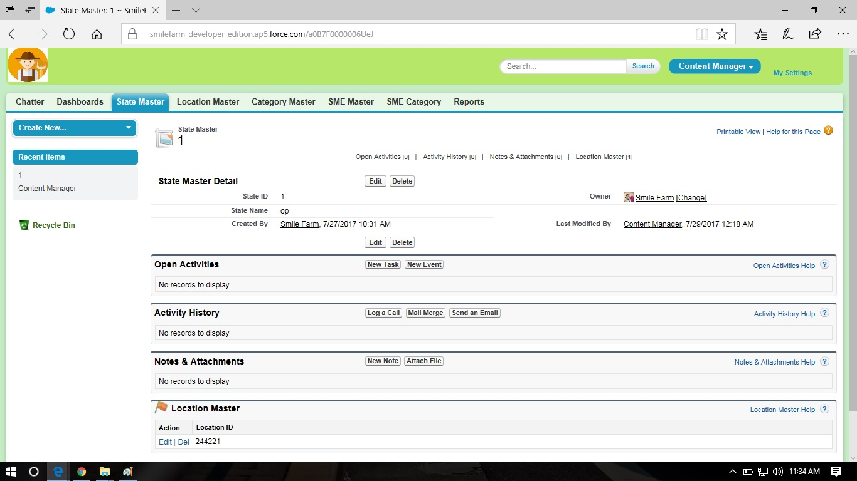**Content Manager Chatter Page:**

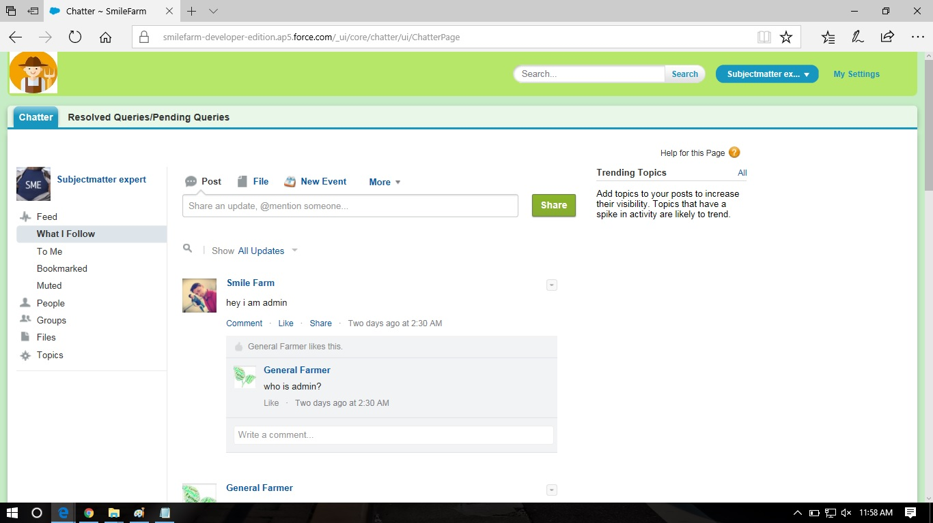**Subject Matter Expert(SME) Chatter Page:**

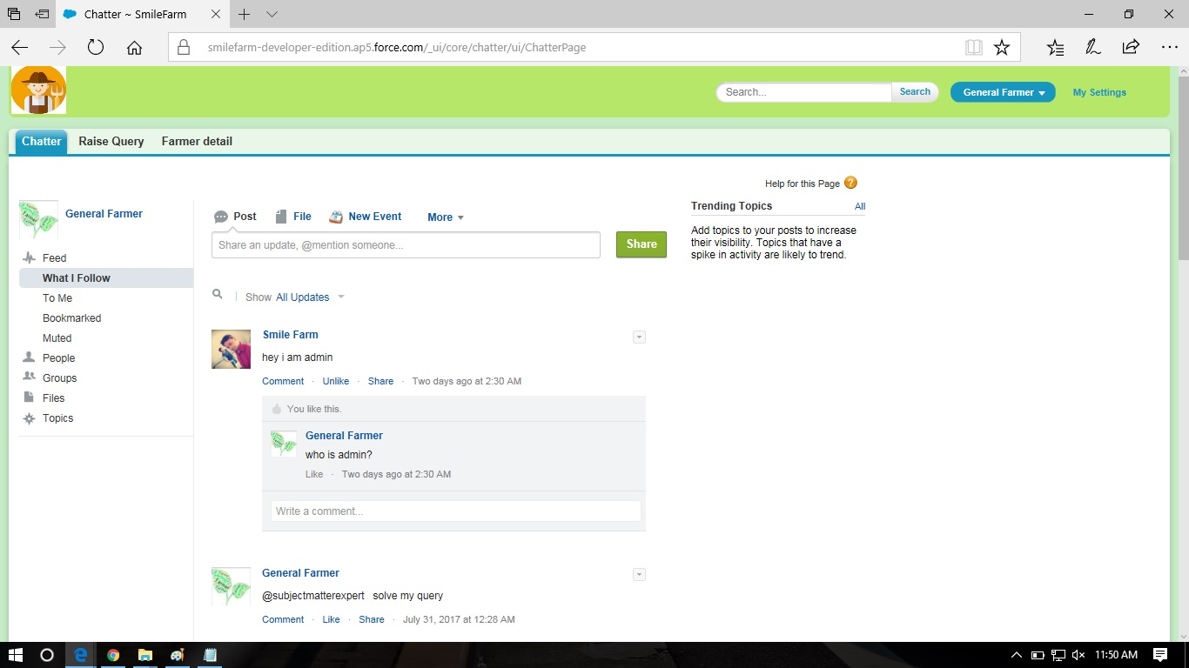**General Farmer Chatter Page:**

**Apex Data Laoder :**

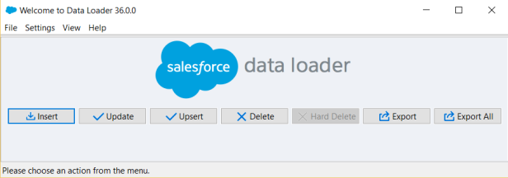

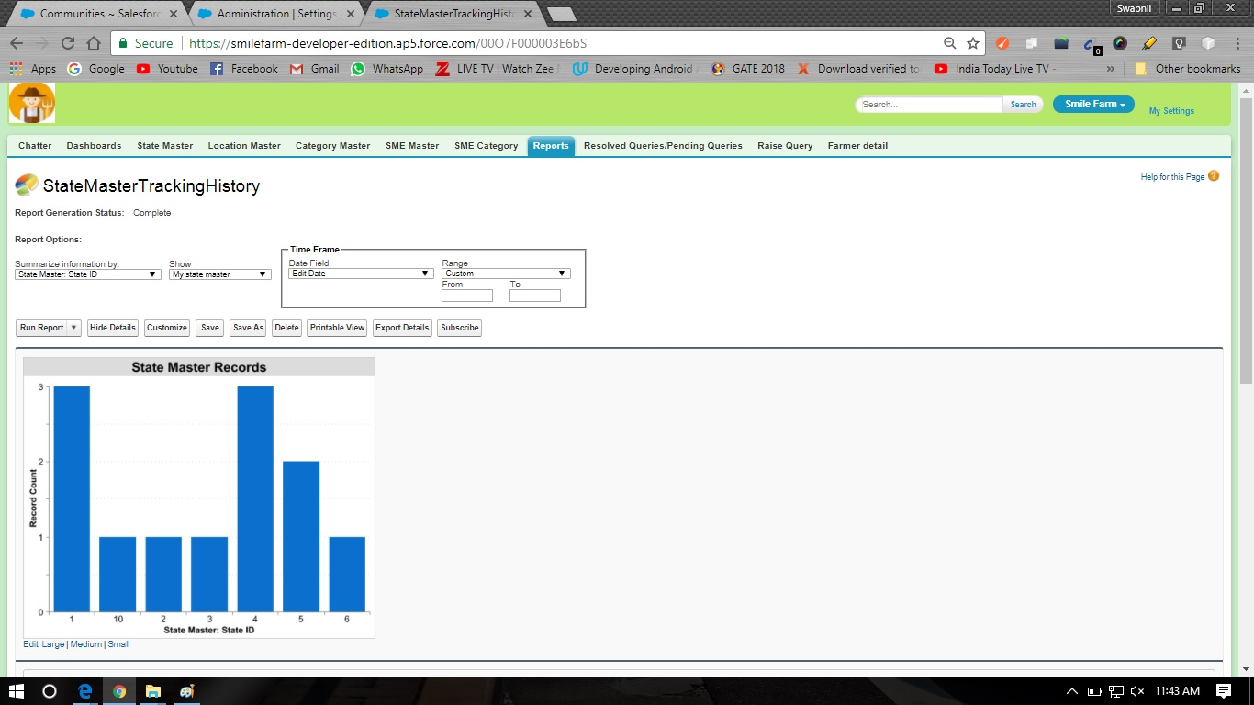**Admin Report Dashboard Page: 1**

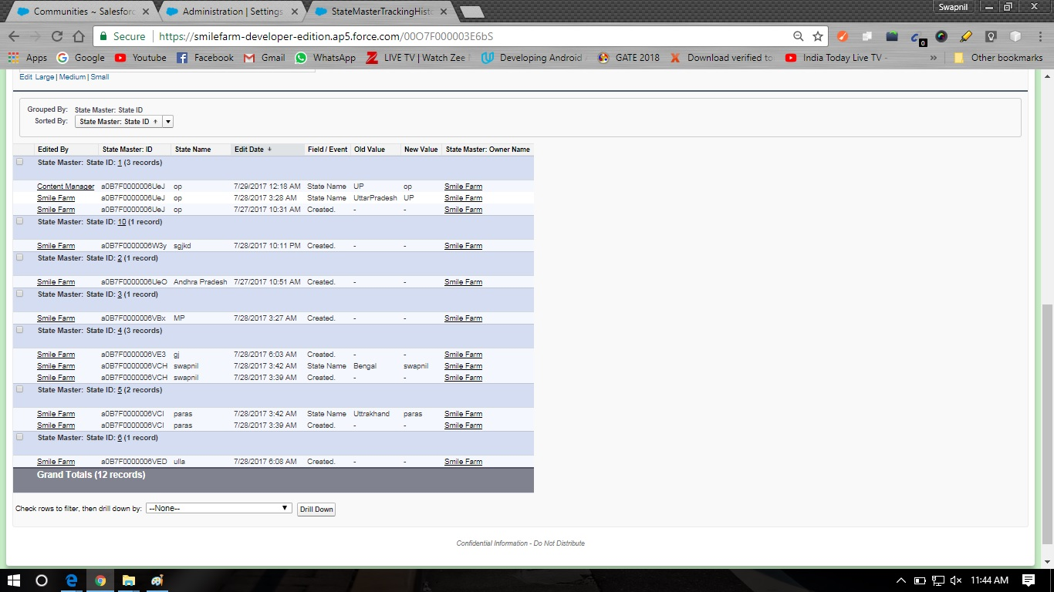**Admin Report Dashboard Page: 2**

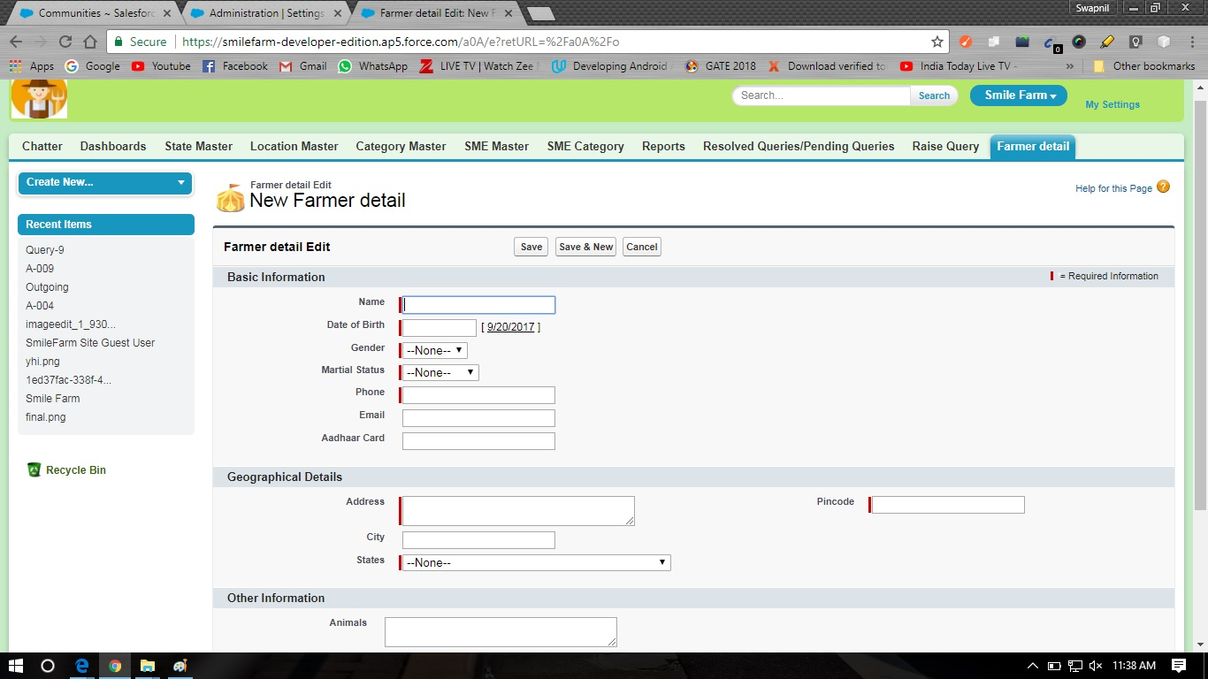**Farmer Form Page:**

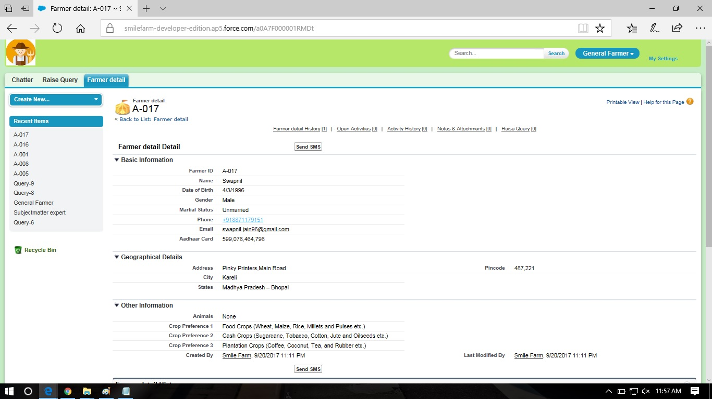**Farmer Detail Page:**

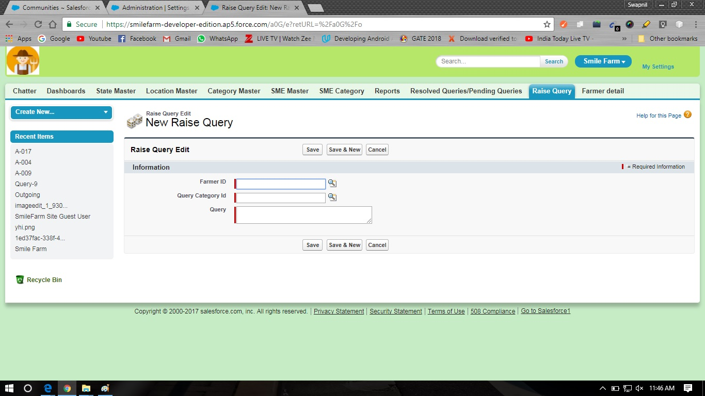**Raise Query Page:**

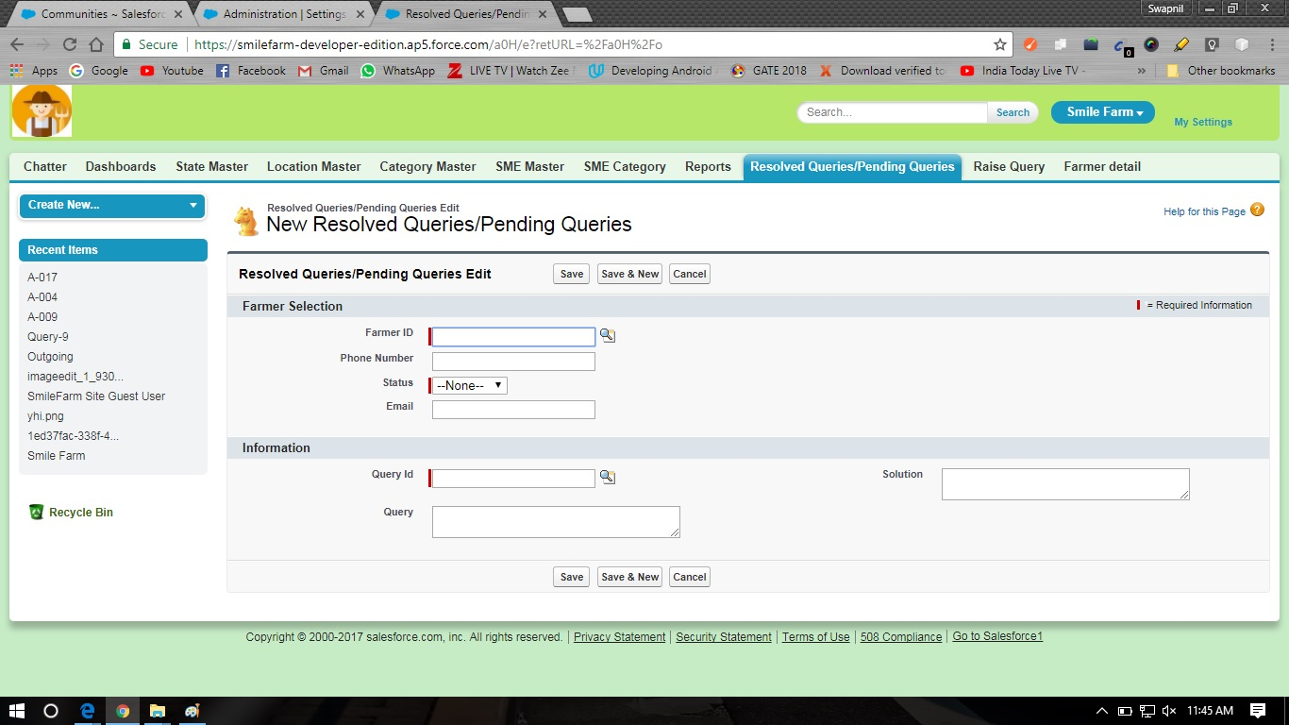**Resolve Query/Pending Query Page:**

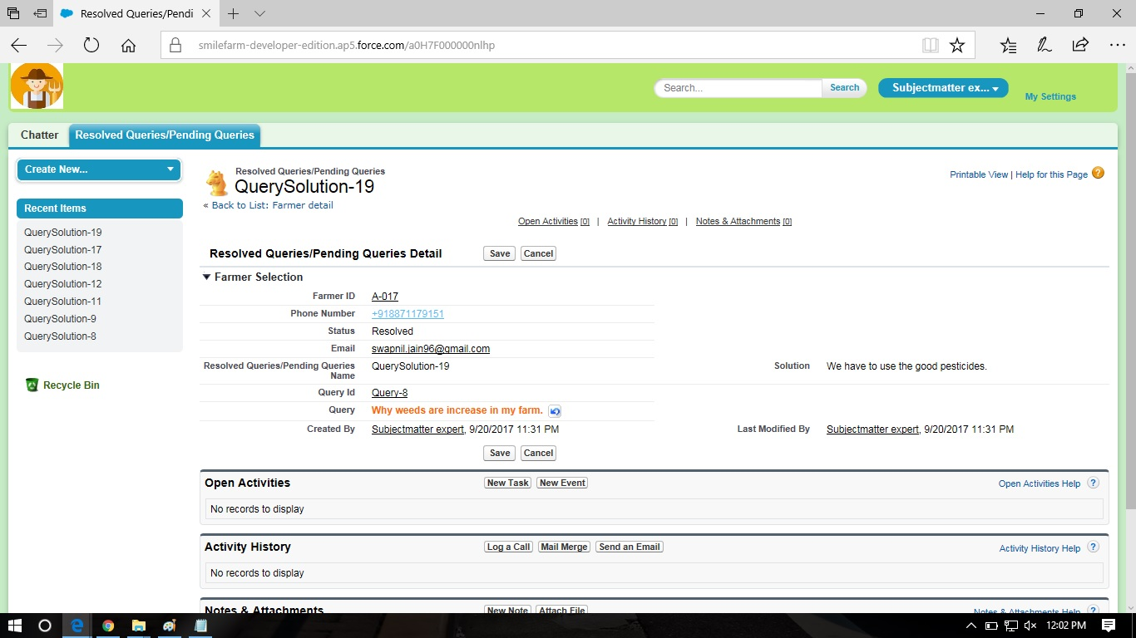**Query Solution Page:**

**Admin Report Tab Page:**

